Laboratory Assignment AND Assessment Requirements Specification

Version 1.0

March, 2020

Developed by:
Student X, Student Y
933
Version History

Version | Description of Change | Author | Date
V01 | Initial | Student X  Student Y | 16.03.2020

Contents
Laboratory Assignment AND Assessment Requirements Specification 1
Version 1.0 1
March, 2020 1
1 Functional Requirements 3
2 Actors 3
3 Use cases – diagram 3
3.1 Use case number 1 (Description of the use case) 3
4 Analysis 3
4.1 Entities 3
4.2 Relations between entities 3
4.3 Attributes 3
4.4 System behavior 4
4.4.1 Use case 1-2-3 4
4.5 System events 4
5 Design 4

Analysis and design Document

Functional Requirements
List the functional requirements (FR) of the system.
Section/ Requirement ID | Requirement Definition
FR1.0. | Add a new student
FR1.1 | Remove a student
FR1.1.1 | Update student

Actors
Teacher

Use cases – diagram
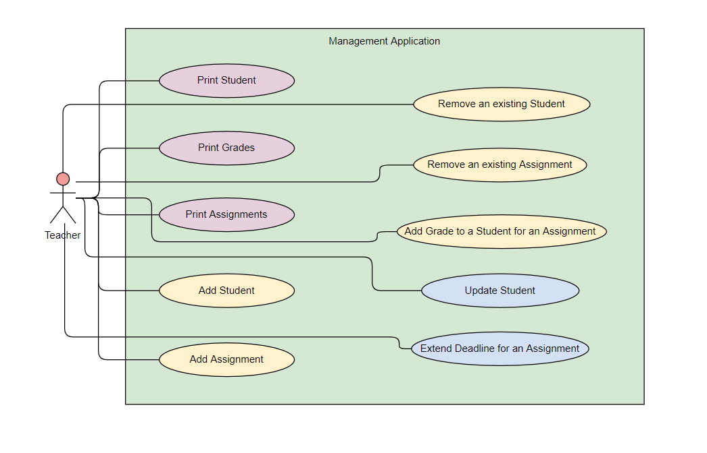

Use case number 1 (Description of the use case)
Actors: teacher
Description: create a new student
Precondition: - all fields are specified
Postcondition: - a new student was added in the list

Action | System Response
1 Completes the necessary fields for adding
 | 2 Checks if everything is alright, adds a new element in the list if so
3 - | 3. If the input is invalid, throws an exception

Exceptions: When the fields aren’t filled.

3.2 Use case number 2 (Description of the use case)

Actors: teacher
Description: delete student
Precondition: - valid id belonging to an existing student is specified
Postcondition: - the student with the specified id is removed from the list

Action | System response
1 Give an id as input
 | 2 Checks if it is a valid id and there is a student with that id and deletes the student
3 - | 3. If the input is invalid, throws an exception

3.3 Use case number 3 (Description of the use case)

Actors: teacher
Description: update student
Precondition: - valid id belonging to an existing student and all other fields for student are specified
Postcondition: - the student with the specified id has the data updated

action | System response
1 Give an id and all other fields for the Student entity as input
 | 2 Checks if it is a valid id and there is a student with that id, than checks if the rest of the input is valid, and updates the data for that student
3 - | 3. If the input is invalid, throws an exception

Analysis

Entities
Student, Assignment, Grade

Relations between entities
One student can have multiple assignments and one assignment can be assigned to many students. It is a many-to-many relationship between the two classes. Class Grade has as id, a pair consisting of studentId and assignmentId and it is the association class between the Student and Assignment classes.

Attributes
Student: id, name, group, email, professor name
Assignment: id, description, deadline, assignation date
Grade: id(studentId, assignmentId), value, deliver date, feedback

System behavior

Use case 1-2-3
The system will act as a subsystem to a larger environment, in order to speed up a certain process in the company’s workflow.

System events
After each operation a message is shown to the user either if the command terminated succesfully or with an error message.

Design
  - Class diagram

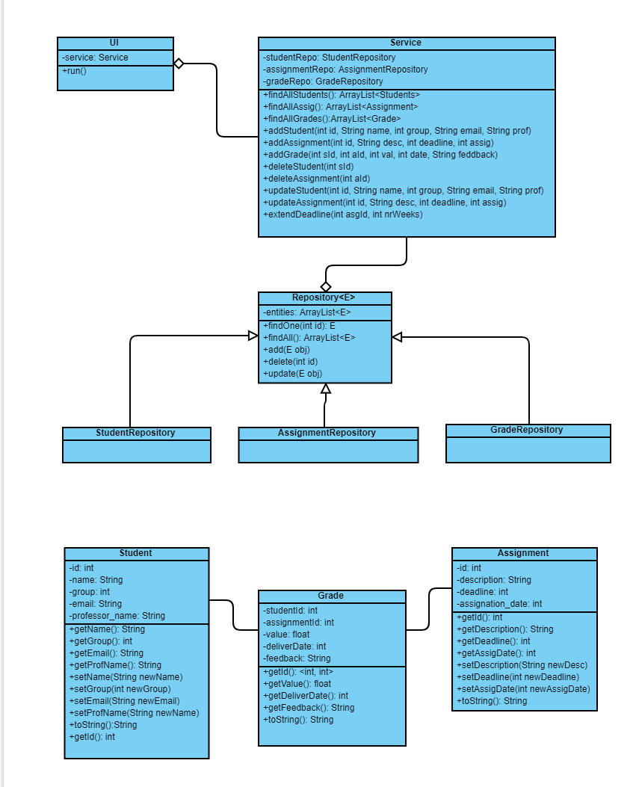

  - Sequence diagrams (for each use case)
- Add Student Sequence Diagram
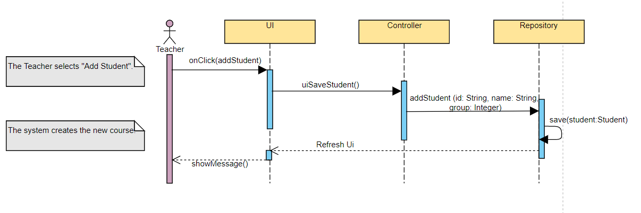

- Delete Student Sequence Diagram
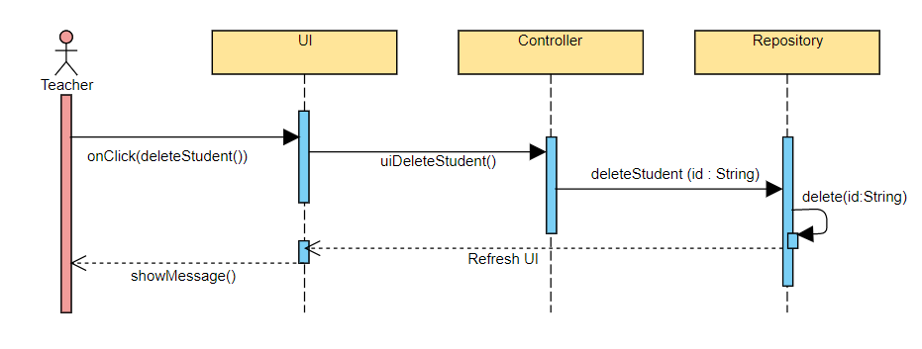
- Update Student Sequence Diagram
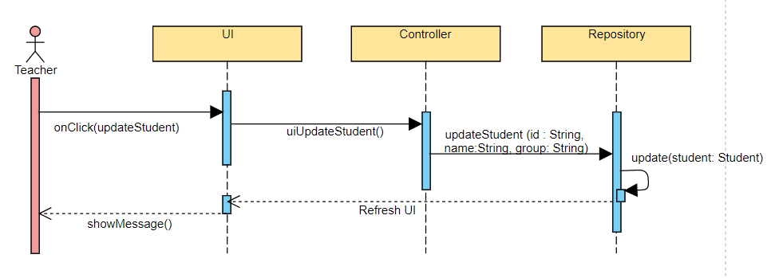
  - GRASP
GRASP is set of exactly 9 General Responsibility Assignment Software Patterns:
1. Information Expert
2. Creator
3. Controller
4. Low Coupling
5. High Cohesion
6. Indirection
7. Polymorphism
8. Pure Fabrication
9. Protected Variations

